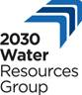

**Multi-stakeholder consultation meeting on climate change**

**And Agri-water use efficiency in Bundelkhand**

Jhansi, 3 June 2016

A multi-stakeholder consultation meeting was jointly organized by 2030 Water Resources Group and PARMARTH SAMAJ SEVI SANSTHAN in Jhansi on 3rd June 2016. The meeting aimed to discuss technical issues related to long-term sustainable solution for drought mitigation in Bundelkhand region of India. In addition, the consultation was focused on exploring options for working on groundwater recharge through restoration of water bodies, agri-water use efficiency and agriculture diversification.

Representatives from 10 CSOs across the Bundelkhand region of Uttar Pradesh & Madhya Pradesh participated in the consultation meeting and shared their work experiences and expertise in drought management and other developmental issues of marginalized community groups.

A draft proposal was presented to the participants and comments and suggestions were requested for making the proposal more comprehensive.

The CSO representatives suggested the need for following measures for long-term sustainable solution for drought mitigation in the Bundelkhand region of Uttar Pradesh & Madhya Pradesh-

* Need collective efforts for increasing resilience power of the community members in the region
* Need to focus on promotion of local contextual coping mechanism to fight climate variability
* Need to involve women and youth groups on water governance agenda
* Need coordination with government departments such as Agriculture, Irrigation, and Rural departments for leveraging resources
* Need to work for alternative livelihood – livestock rearing, etc.
* Need to mobilize MGNREGA & other government schemes through collectivization

The Irrigation Department attended the consultation and assured their support in taking forward the agenda for long term sustainable solution of drought mitigation. They assured to provide technical support in water conservation, protection and management.

ICAR – CAFRI, Jhansi shared the watershed development work of their organization. They suggested the incorporation of technical data in the project proposal.

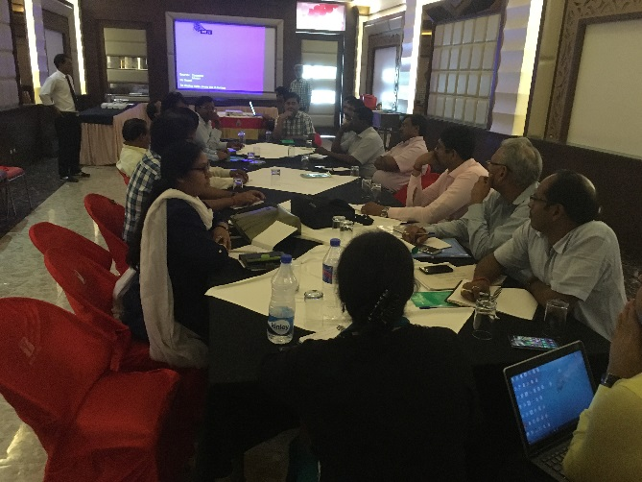 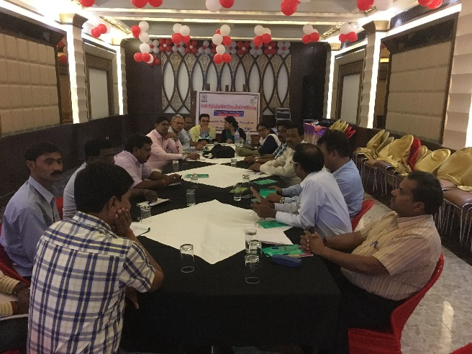

Divisional Coordinator- Panchayat Raj, Jhansi assured the support of Panchayat Raj in taking forward the agenda of drought mitigation and drought management.

Additional Director, Soil Department, suggested the need to focus on the soil health of the region and respecting the traditional knowledge of the people for reducing the impact of drought vulnerability.

India Water Partnership and 2030 Water Resource Group facilitated the discussion. **Key Suggestions that emerged during the consultation-**

* Interventions should be planned for a longer duration
* Situational analysis needs to be done for the proposed targeted villages
* Analysis of water bodies should be done through secondary data assessment
* Use of secondary information, previous studies/research papers related to Bundelkhand issues mainly of water and soil conservation
* Formation of a consortium for planning, designing, execution, implementation and monitoring of the proposed action – clear cut role division and responsibilities need to be defined
* Need to incorporate technical aspects in the proposal like hydrological condition, soil structure, rainfall, run off, water saving potential, etc.
* Need to develop project proposal collectively and incorporate the experiences of previous work / model of Development Alternative / PARMARTH / CAFRI (Central Research Institutes for Dryland Agriculture , Hyderabad)
* Need to incorporate the expertise of different CSOs
* Need to conduct research study in the areas for preparation of comprehensive project proposal

**Future Action Plan**

* Sharing of draft proposal among team members for comments and suggestions
* Revision of proposal needs to be prepared by 30th June
* Internal meeting with consortium representatives